**FASHION HEAVEN:**

**INTRODUCTION**

Fashion heaven, an online retail store, leverages Zoho books to manage their inventory and track sales, we can generate invoices and manage customer payments seamlessly. Zoho books also enables them to reconcile bank transaction and generate financial reports, helping them make informed decisions about their business.

Fashion heaven is a private limited company also registered under GST in Tamil Nadu. Fashion heaven is a retailor of various lifestyle products in wholesale and retail. It has a wide range of customers all over the state and it procures from various suppliers in the state. It operates at a loss instead of a profit.

**OBJECTIVES:**

* The customer satisfaction of main aim in our company.
* The products are low budget and highly quality.
* Introduce new designs and collections in our company.

**REVIEW:**

* Our company manufactured only good quality products.
* We have buy one get offer.
* If the products are damaged come to an exchange in our company.

**STATEMENT OF PROBLEM:**

There are many problems faced in zoho books. Technical errors and they have only gave to the help for in zoho books. They have minimum time duration gave to the zoho books.

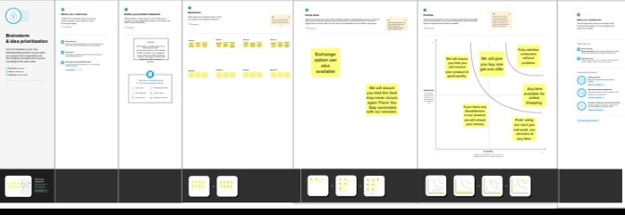

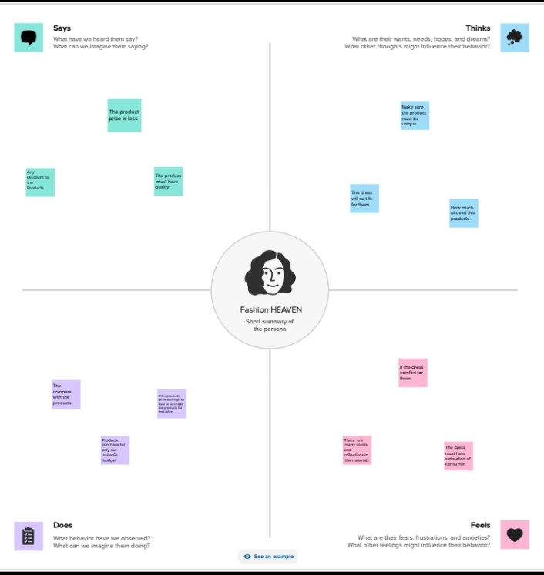

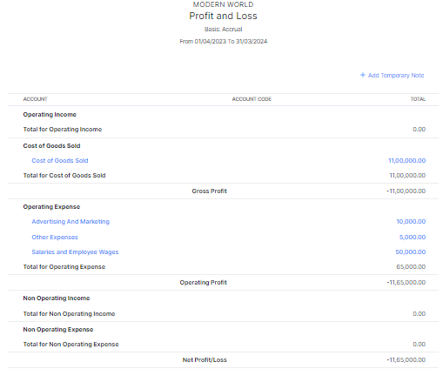

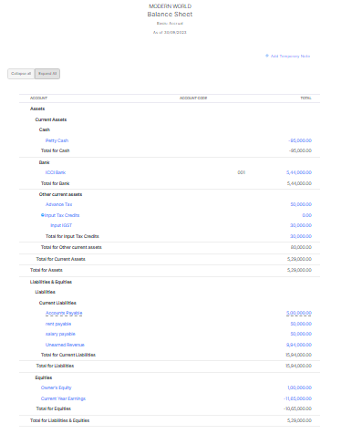

CONCLUSION:

Finally our project completed. We had a mistake for process so we got a loss instead of profit. Thank you for the wonderful opportunity sir. This software very useful for us.